**We installed IntelliJ from the official site of Jet brains**

Today we downloaded IntelliJ IDEA IDE for generating the Spark code.

IntelliJ IDEA IDE is the most powerful Integrated Development Enterprise

This IDE is loaded with rich features and functionalities

**Features of IntelliJ IDEA IDE**

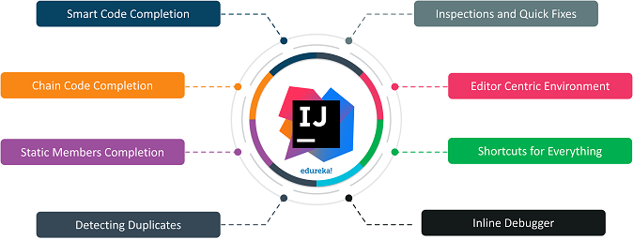

**Installation of IntelliJ IDEA IDE**

We installed IntelliJ from the official site of Jet brains and have chosen the version as per your requirements. Few prerequisites are:

* A programming language like Python, Scala and Java. Here we shall choose Scala.
* Download JDK and JRE.
* Set Java Home and Java Path.
* Download IntelliJ IDEA IDE Community Version
* Go to downloads and extract IntelliJ

**IntelliJ-IDEA-IDE-Installation-Windows**

Run the .exe file

Since we wish to work with some build tools and frameworks like Maven and Spark, so we installed them as well and set up the home path requirements for them too.

**Environment Testing**

object ScalaDemo {

def main(args: Array[String]): Unit = {

println("Hello world ! My first scala program.")

var a = 3

var b = 5

var c = a +b

println("a+b = " + c)

} }

object HelloWorld1 {

def main(args: Array[String]) {

println("Hello World1")

}

}

import org.apache.spark.sql.SparkSession

object SparkScalaDemo {

def main(args: Array[String]): Unit = {

println("Hello Spark Scala")

// Create a Spark Session

val spark = SparkSession

.builder

.appName("HelloSpark")

.config("spark.master", "local")

.getOrCreate()

println("Created Spark Session")

val sampleSeq = Seq((1,"spark"),(2,"Big Data"))

val df = spark.createDataFrame(sampleSeq).toDF("course id", "course name")

df.show()

}

}

**Why we choose IntelliJ?**

* **Debugging:** In Eclipse press Ctrl+Shift+I to evaluate the expression. If you fail to select the complete expression, then eclipse cannot evaluate it. But in IntelliJ, you just to hover over to the expression you wish to evaluate and press Atl+F8 and its done.
* **Auto code complete:** IntelliJ has the ability to decode the context and provide suggestions to the user.
* **Code Refactoring:** Unlike the other IDEs, IntelliJ offers intelligent code refactoring. It realizes what exactly you wish to type.

